-= 10 Gb New Rad =-
Tuesday 28 March 2023
08:36

Infortmation on New RAD ETX-2i 10G-B, replacing RAD ETX-220A



Hi all,
Over the next few weeks we will see orders for the New RAD box ETX-2i 10G-B which is replacing the RAD ETX-220A.
please see attached documents. including basic config file
List of Fiori store codes.

Material | Material Description | 8 | Requirement Quantity | What Equipment | What Port | 1G or 10G | Add.1 | Distance
5011730 | ETX2i-10 Gig NTU DC Redundant Hardened |  | 0 | NTU : Dual DC |  | 10G | Temp. Hardened
5011731 | ETX2i-10 Gig NTU DC Redundant |  | 0 | NTU : Dual DC |  | 10G | Standard
5011732 | ETX2i-10 Gig NTU AC Redundant |  | 0 | NTU : Dual AC |  | 10G | Standard
5011750 | SFPP-10G-40km-SM-1550nm |  | 0 | Optic : Uni-Directional | Cust. Facing Port | 10G | Standard | 40km
5011751 | SFPP-10G-40km-SM-1550nm-I-temp |  | 0 | Optic : Uni-Directional | Cust. Facing Port | 10G | Temp. Hardened | 40km
5011752 | SFPP-10G-10km-SM-1310nm |  | 0 | Optic : Uni-Directional | Cust. Facing Port | 10G | Standard | 10km
5011753 | SFPP-10G-10km-SM-1310nm-I-temp |  | 0 | Optic : Uni-Directional | Cust. Facing Port | 10G | Temp. Hardened | 10km
5011754 | SFPP-10G-80km-SM-1550nm-DDM |  | 0 | Optic : Uni-Directional | Cust. Facing Port | 10G | Standard | 80km
5011755 | SFPP-10G-300m-MM-850nm |  | 0 | Optic : Uni-Directional | Cust. Facing Port | 10G | Standard | 300m
5011756 | SFPP-10G-80km-SM-1550nm-I-temp-DDM |  | 0 | Optic : Uni-Directional | Cust. Facing Port | 10G | Temp. Hardened | 80km
5011757 | SFPP-10G-40km-BiDi-Tx1270/Rx1330 |  | 0 | Optic : Bi-Directional | NTU Net. Port | 10G | Standard | 40km
5011758 | SFPP-10G-10km-BiDi-Tx1270/Rx1330-I-temp |  | 0 | Optic : Bi-Directional | NTU Net. Port | 10G | Temp. Hardened | 10km
5011759 | SFPP-10G-10km-BiDi-Tx1270/Rx1330 |  | 0 | Optic : Bi-Directional | NTU Net. Port | 10G | Standard | 10km
5011760 | SFPP-10G-40km-BiDi-Tx1270/Rx1330-I-temp |  | 0 | Optic : Bi-Directional | NTU Net. Port | 10G | Temp. Hardened | 40km

Material | Material Description | Stock | What Equipment | What Port | 1G or 10G | Add.1 | Distance
5011730 | ETX2i-10 Gig NTU DC Redundant Hardened | 0 | NTU : Dual DC |  | 10G | Temp. Hardened
5011731 | ETX2i-10 Gig NTU DC Redundant | 80 | NTU : Dual DC |  | 10G | Standard
5011732 | ETX2i-10 Gig NTU AC Redundant | 90 | NTU : Dual AC |  | 10G | Standard
5011750 | SFPP-10G-40km-SM-1550nm | 2 | Optic : Uni-Directional | Cust. Facing Port | 10G | Standard | 40km
5011751 | SFPP-10G-40km-SM-1550nm-I-temp | 2 | Optic : Uni-Directional | Cust. Facing Port | 10G | Temp. Hardened | 40km
5011752 | SFPP-10G-10km-SM-1310nm | 240 | Optic : Uni-Directional | Cust. Facing Port | 10G | Standard | 10km
5011753 | SFPP-10G-10km-SM-1310nm-I-temp | 100 | Optic : Uni-Directional | Cust. Facing Port | 10G | Temp. Hardened | 10km
5011754 | SFPP-10G-80km-SM-1550nm-DDM | 2 | Optic : Uni-Directional | Cust. Facing Port | 10G | Standard | 80km
5011755 | SFPP-10G-300m-MM-850nm | 15 | Optic : Uni-Directional | Cust. Facing Port | 10G | Standard | 300m
5011756 | SFPP-10G-80km-SM-1550nm-I-temp-DDM | 2 | Optic : Uni-Directional | Cust. Facing Port | 10G | Temp. Hardened | 80km
5011757 | SFPP-10G-40km-BiDi-Tx1270/Rx1330 | 8 | Optic : Bi-Directional | NTU Net. Port | 10G | Standard | 40km
5011758 | SFPP-10G-10km-BiDi-Tx1270/Rx1330-I-temp | 70 | Optic : Bi-Directional | NTU Net. Port | 10G | Temp. Hardened | 10km
5011759 | SFPP-10G-10km-BiDi-Tx1270/Rx1330 | 220 | Optic : Bi-Directional | NTU Net. Port | 10G | Standard | 10km
5011760 | SFPP-10G-40km-BiDi-Tx1270/Rx1330-I-temp | 5 | Optic : Bi-Directional | NTU Net. Port | 10G | Temp. Hardened | 40km

From <https://mail.google.com/mail/u/0/popout?ver=gpyz7m7kmnt5&search=inbox&th=%23thread-f%3A1761508426201414241&cvid=1>

https://photos.app.goo.gl/i9QdajNqvtGNoeor8

Material | Material Description | What Equipment | What Port | 1G or 10G | Add.1 | Distance
5011730 | ETX2i-10 Gig NTU DC Redundant Hardened | NTU : Dual DC |  | 10G | Temp. Hardened
5011731 | ETX2i-10 Gig NTU DC Redundant | NTU : Dual DC |  | 10G | Standard
5011732 | ETX2i-10 Gig NTU AC Redundant | NTU : Dual AC |  | 10G | Standard
5011750 | SFPP-10G-40km-SM-1550nm | Optic : Uni-Directional | Cust. Facing Port | 10G | Standard | 40km
5011751 | SFPP-10G-40km-SM-1550nm-I-temp | Optic : Uni-Directional | Cust. Facing Port | 10G | Temp. Hardened | 40km
5011752 | SFPP-10G-10km-SM-1310nm | Optic : Uni-Directional | Cust. Facing Port | 10G | Standard | 10km
5011753 | SFPP-10G-10km-SM-1310nm-I-temp | Optic : Uni-Directional | Cust. Facing Port | 10G | Temp. Hardened | 10km
5011754 | SFPP-10G-80km-SM-1550nm-DDM | Optic : Uni-Directional | Cust. Facing Port | 10G | Standard | 80km
5011755 | SFPP-10G-300m-MM-850nm | Optic : Uni-Directional | Cust. Facing Port | 10G | Standard | 300m
5011756 | SFPP-10G-80km-SM-1550nm-I-temp-DDM | Optic : Uni-Directional | Cust. Facing Port | 10G | Temp. Hardened | 80km
5011757 | SFPP-10G-40km-BiDi-Tx1270/Rx1330 | Optic : Bi-Directional | NTU Net. Port | 10G | Standard | 40km
5011758 | SFPP-10G-10km-BiDi-Tx1270/Rx1330-I-temp | Optic : Bi-Directional | NTU Net. Port | 10G | Temp. Hardened | 10km
5011759 | SFPP-10G-10km-BiDi-Tx1270/Rx1330 | Optic : Bi-Directional | NTU Net. Port | 10G | Standard | 10km
5011760 | SFPP-10G-40km-BiDi-Tx1270/Rx1330-I-temp | Optic : Bi-Directional | NTU Net. Port | 10G | Temp. Hardened | 40km

 | Rad | AGG | Rad | Agg
Material | 5011752 | 5011553 | 5011759 | 5011503
Material Description | SFPP-10G-10km-SM-1310nm | SFPP-10G-10km-SM-1310nm-I-temp | SFPP-10G-10km-BiDi-Tx1270/Rx1330 | 10 GBASE-BX-10
What Equipment | Optic : Uni-Directional | Optic : Uni-Directional | Optic : Bi-Directional | Bi Directional
What Port | Port 3 | Cust. Facing Port | NTU Net. Port | Agg Node
Add.1 | Standard | Temp. Hardened | Standard
Distance | 10km | 10km | 10km
 | 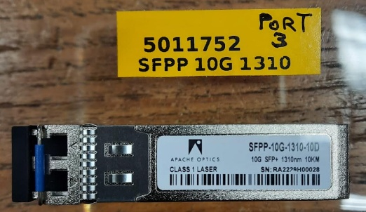 | 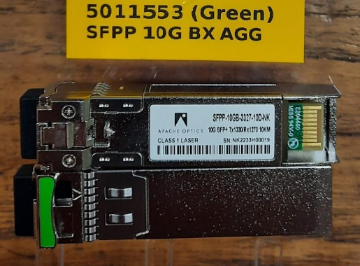 | 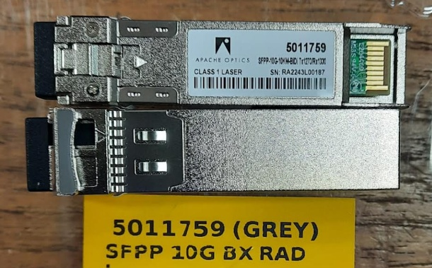 | 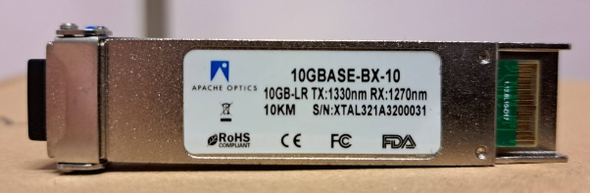  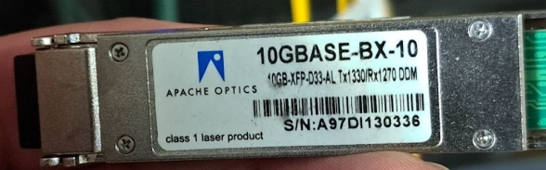

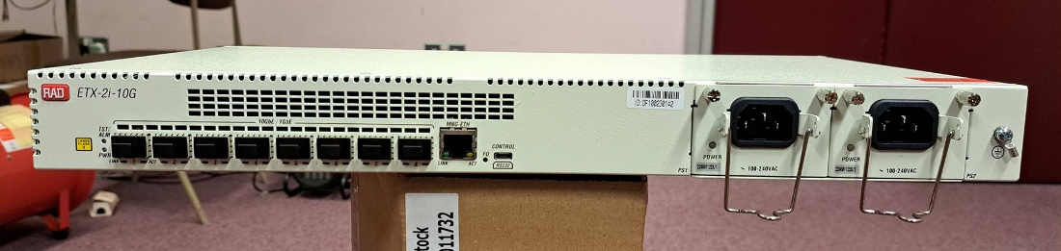  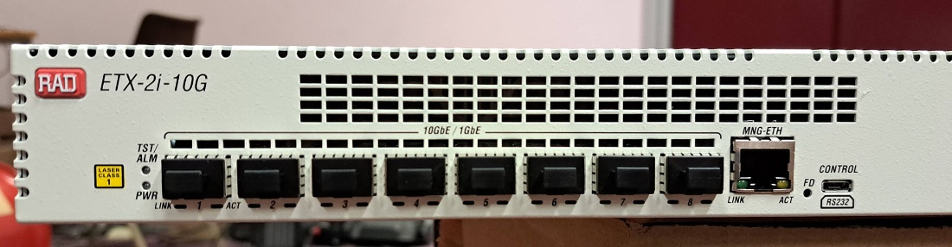 | 10 Gbit Rad Box Dual Power AC  Port 1 Main GBIC  Port 3 - Port 3 GBIC
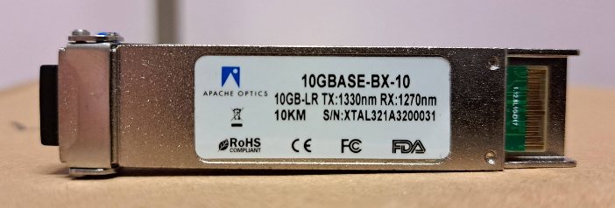 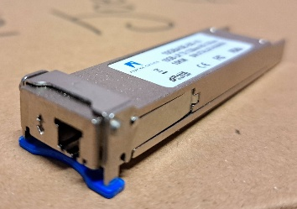 | GBIC for the AGG node
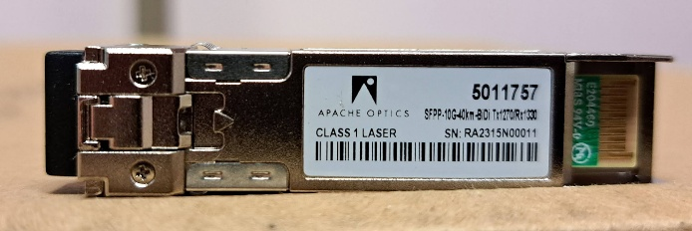 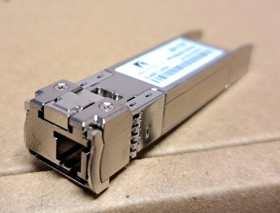 | GBIC for the NET port on the Rad box
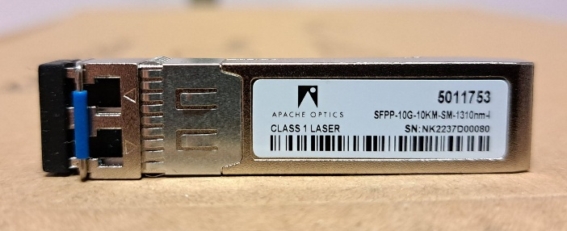  | GBIC for the port 3 on the Rad box
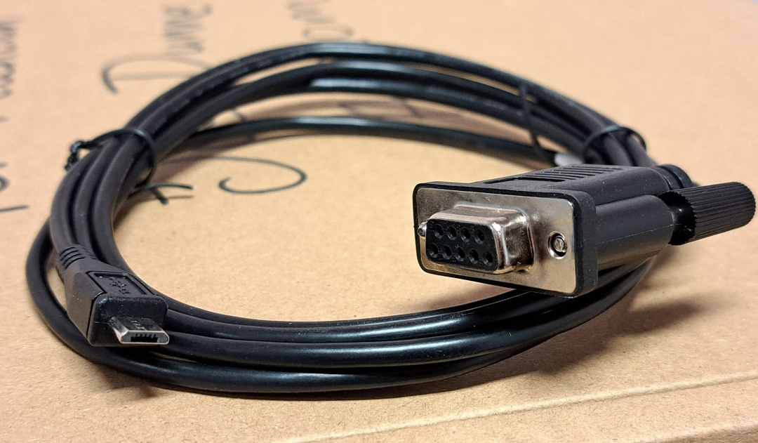 | New microUSB cable for configuring the Rad box
